**Configuring Selenium Set up In the Eclipse.**

Step 1: install java jdk above 1.6

Step 2: download apache-maven-3.0.4 and unzip and copy in the C: Drive

Step3: Download Eclipse IDE above 3.1 version and unzip and copy in the C: Drive

Step4: set the class path variables in the environment variable (right click on my computer ->Click on Environment Variables)

Step 5:

**In the User variables Section**

* JAVA_HOME = C:\Program Files\Java\jdk1.8.0_25
* M2_HOME = C:\apache-maven-3.0.4
* MAVEN_OPTS = -Xms256m -Xmx512m
* ME = C:\apache-maven-3.0.4\bin

**In the System variables Section**

* Path = C:\apache-maven-3.0.4\bin;C:\Program Files\Java\jdk1.6.0_25\bin

Step 6: Open the Eclipse click on Help -> click on Install new Software

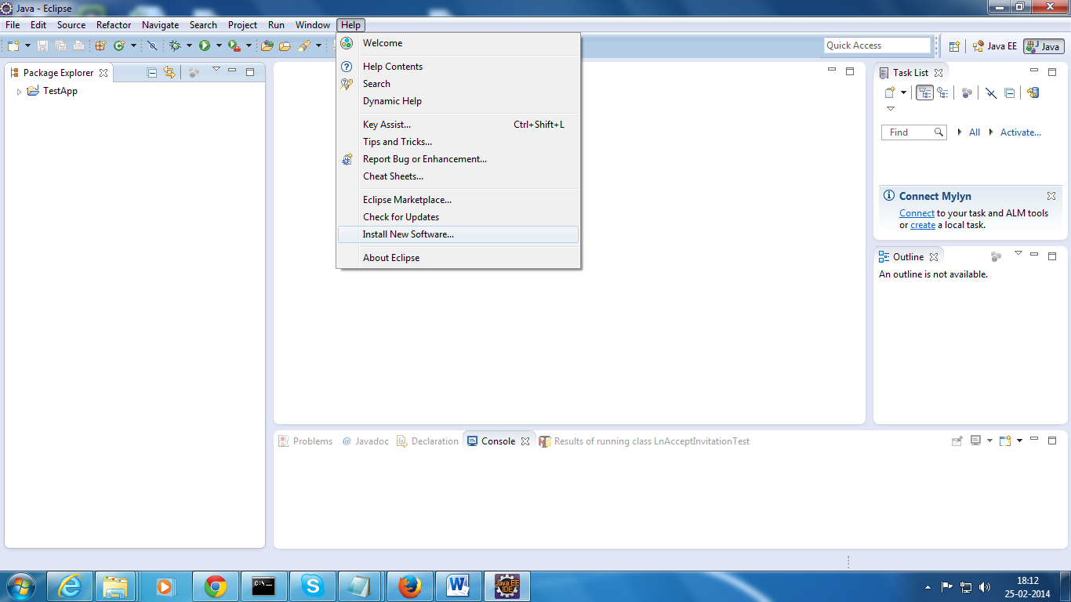

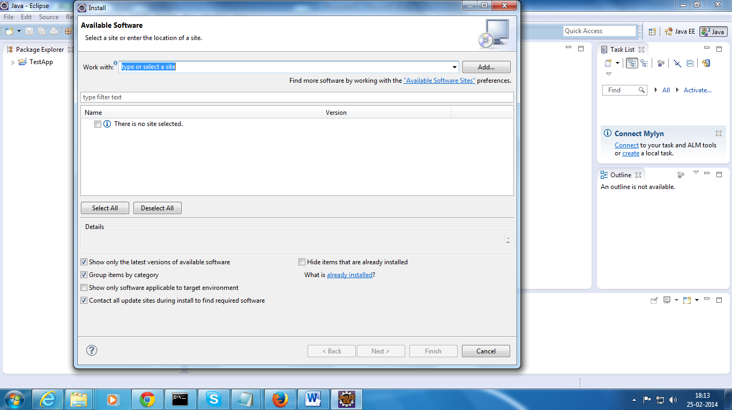

Click on add will get pop up window like below Screen shot.

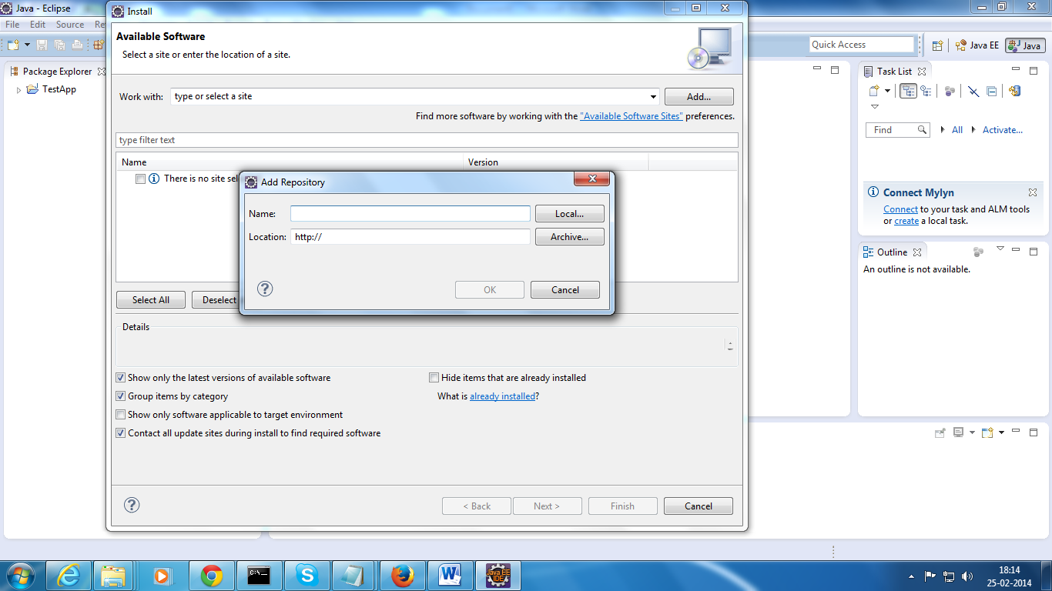

Step 7: For maven integration into the Eclipse

* In the above Pop up’s name field enter valid name like ‘Maven’
* In the above Pop up’s Location field enter The Below Url
* <http://download.eclipse.org/technology/m2e/releases/1.1/1.1.0.20120530-0009>
* It will take some time after completing the update restart the eclipse.

Step 8: For TestNg Integration into the Eclipse

* Repeat the step 6 and you will get the same Pop Up
* In the above Pop up’s name field enter valid name like ‘TestNG’
* In the above Pop up’s Location field enter The Below Url
* <http://beust.com/eclipse>
* It will take some time after completing the update restart the eclipse.

Step 9: Pull Out Socnet Automation From the Git. And keep in local work space.

Step 10: Import the Project from the local work space refer below Screen Shot.

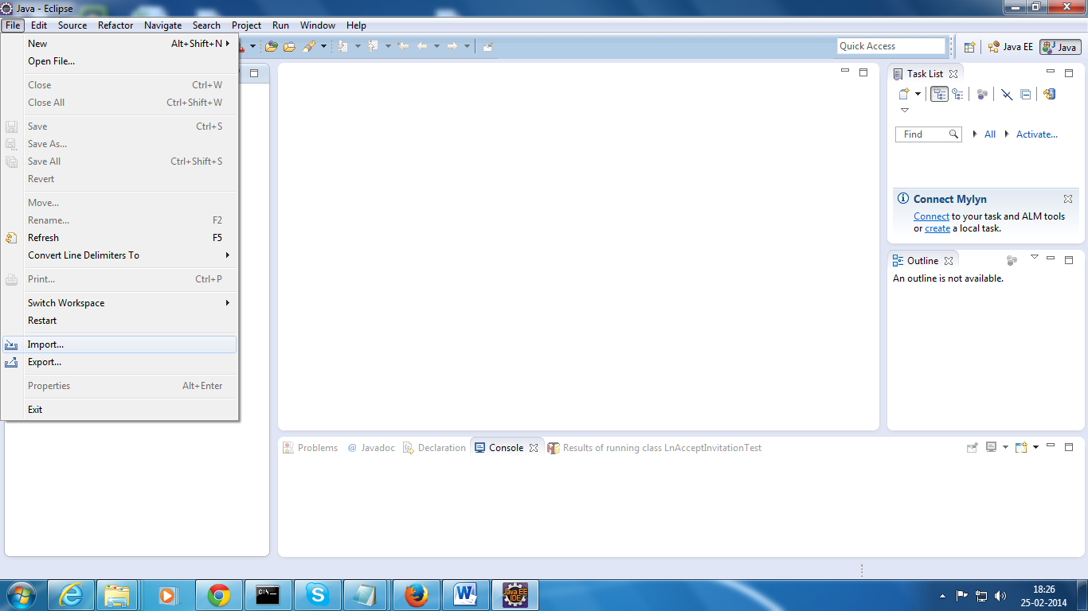

Select->’ Existing Project into the work space’

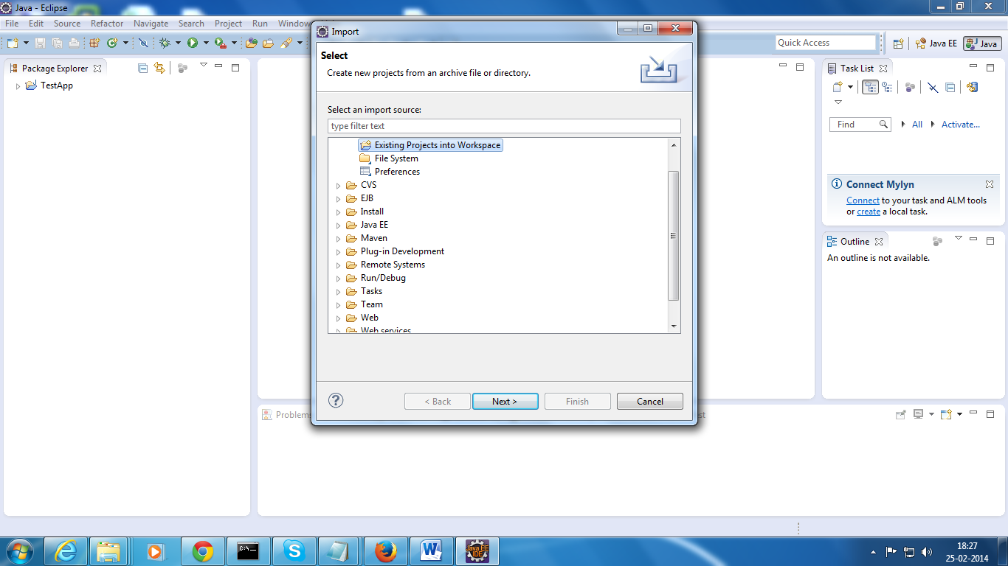

Click on Next Button refer above Screen Shot

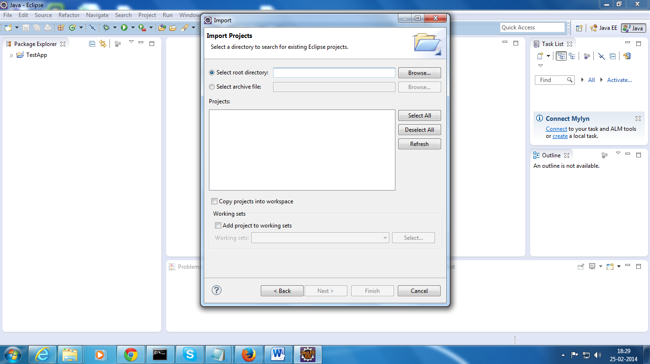

Click on Browse Button browse your project.

Step 10: for running the Script

* Right click on Project->TestNG-Convert Testng and generate testng.xml
* From eclipse right click on the scripts -> Click on Run As TestNG